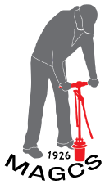
MAGCS Employee Turf Scholarship Application

Qualifications
Applicants must be:
A MAGCS member or an employee (full or seasonal) of a MAGCS Regular (A or B) member who has expressed interest in pursuing a career in golf course management.

Awarded funds are to be used to pursue interest in golf course management for class work/workshops/online education/seminars or other industry recognized educational opportunities.

Applicant Information:
Name:
Address (street, city, state):
Phone:
Email:

Employment History:

Education History:

MAGCS Member Sponsor (must be Class A or B, Regular Member):

To be filled out by applicant. Please answer the following questions:

- Why are you interested in the golf course superintendent profession?
- If the scholarship is won, how do you intend to use the funds?

Please return to (email is fine) luke@magcs.org or mail to MAGCS, 11855 Archer Avenue, Lemont, IL 60439.

Deadline is June 15, 2018

