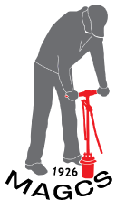
MAGCS Employee Turf Scholarship
Letter of Support

Qualifications
Applicants must be:
A MAGCS member or an employee (full or seasonal) of a MAGCS Regular (A or B) member who has expressed interest in pursuing a career in golf course management.

Applicant Information:
Name:
Club/Course:
MAGCS Member Sponsor (must be Class A or B, Regular Member):

Please write a brief recommendation why this individual should be awarded the MAGCS Turf Scholarship:

Please return to (email is fine) luke@magcs.org or mail to MAGCS, 11855 Archer Avenue, Lemont, IL 60439.

Deadline is June 15, 2018

